"I am Humanist, which means, in part,
that I have tried to behave decently
without expectations of rewards or
punishment after I am dead."
-- Kurt Vonnegut
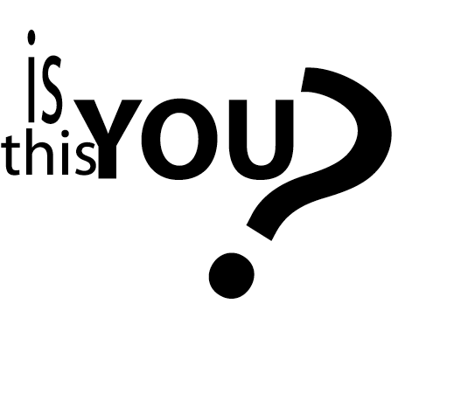

If so, you're invited
to be part of a new
Humanist community
in the Des Moines area.
Contact ________ at ________.

