Inaugural Humanist Event!

Humanists in Des Moines and surrounding communities have decided to organize and you are invited to attend the first meeting of this new and exciting group.
Meet fellow
Humanists
&
like-minded
freethinkers!

Find fellow Humanists and other like-minded freethinkers at the First Unitarian Church of Des Moines:

1800 Bell Avenue

Thursday August 15, 2002
7pm

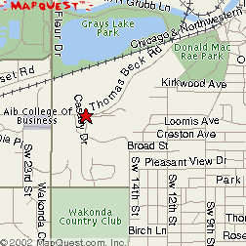
“Humanism is progressive lifestance that,
without supernaturalism, affirms our ability and responsibility to lead meaningful, ethical lives capable of adding to the greater good of humanity.”
-Taken from the American Humanist Association

For more information, contact John Doe (555) 121-1212 doe@youremail.org

